**Low-Level Design (LLD)**

**1. System Components**

* **CSV Input Validator**: Validates and reads the input CSV file.
* **Image Processor**: Downloads and compresses images from URLs.
* **Database Manager**: Manages the SQL database interactions, such as inserting and updating records.
* **CSV Output Generator**: Writes the final processed data to an output CSV.
* **Main Controller**: Orchestrates the flow of data through the system.

**2. Component Breakdown**

**A. CSV Input Validator**

This component handles the reading and validation of the input CSV.

* **Class/Module**: csv_validator
  + **Methods**:
    1. **validate_csv(df: pd.DataFrame) -> None**  
       Validates that the required columns are present and there are no null values.

**B. Image Processor**

This component is responsible for downloading and compressing images.

* **Class/Module**: ImageProcessor
  + **Methods**:
    1. **download_image(url: str) -> Image**  
       Downloads the image from the provided URL and returns an Image object from PIL.
    2. **compress_image(image: Image, output_dir: str) -> str**  
       Compresses the image by 50%, saves it locally, and returns the file path.
    3. **process_image(image_url: str, output_dir: str) -> str**  
       A wrapper that combines downloading and compressing and returns the final output path or None in case of an error.

**C. Database Manager**

Handles SQL database interaction for storing and retrieving the status of image processing requests.

* **Class/Module**: get_sql_connection
  + **Attributes**:
    - connection: SQL connection object
  + **Methods**:
    - **get_connection() -> Connection**  
      returns SQL connection object.

**D. Main Controller**

Coordinates the entire process.

* **Class/Module**: main
  + **Attributes**:
  + **Methods**:
    - **generate_request_id() -> str**  
      Generates a unique request ID using uuid.
    - **process_csv(input_csv: str, output_csv: str) -> None**  
      Orchestrates the entire process:
      * Reads and validates the CSV.
      * Inserts request details into the database.
      * Downloads and compresses images.
      * Updates the database and writes output to a new CSV.

**3. Process Flow**

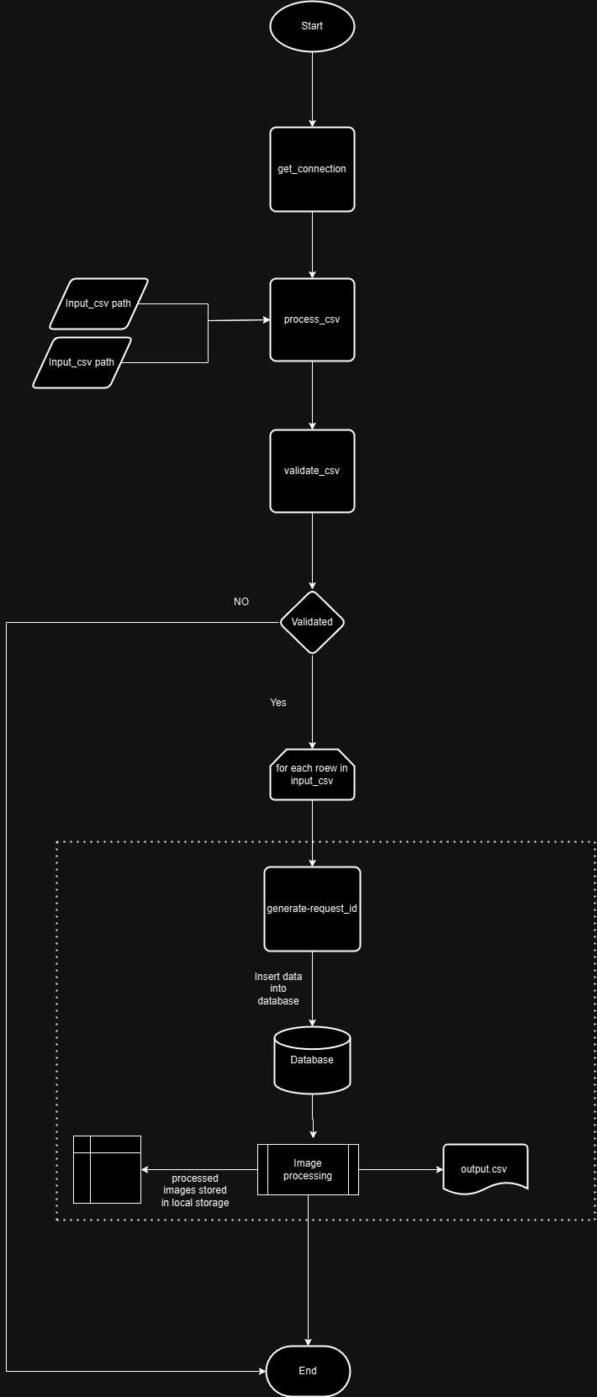

**5. Sequence Diagram**

plaintext

Copy code

+-----------+ +-----------+ +-----------+ +-----------+

| CSV File | | Pipeline | | SQL DB | | Output CSV|

+-----------+ +-----------+ +-----------+ +-----------+

| | | |

| read_csv() | | |

|------------------> | |

| | | |

| validate_csv() | | |

|------------------> | |

| | | |

| insert_request()| | |

|----------------->| | |

| | INSERT INTO | |

| |------------------>| |

| | | |

| process_image() | | |

|----------------->| | |

| | | |

| update_request()| | |

|----------------->| | |

| | UPDATE status | |

| |------------------>| |

| | | |

| write_csv() | | |

|--------------------------------------------------------->|

| | | |

| | | |